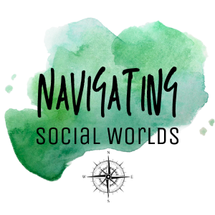
REGISTRATION FORM
Conducting social research online and offline: opportunities, risks and challenges
23–24 November 2022, Warsaw (Poland)

An international conference organised by the Middle East and Central Asia Unit,
SGH Warsaw School of Economics

Name and surname:

Academic degree:

Affiliation:

Title of presentation:

Abstract
(around 300 words):

Bio:

Would you like to participate in methodological workshop? | □ YES  □ NO

Please submit your registration form in pdf format until 20 September 2022 to Agnieszka Syliwoniuk-Wapowska, PhD – assistant professor at asyliw [at] sgh.waw.pl.

